

Read Data Firestore Database

Pemrograman Mobile II

**ADD DATA**

1. Buat view baru di module mahasiswa. Perintah sebagai berikut

get create view:mahasiswa_update on mahasiswa

get create view:mahasiswa_add on mahasiswa

1. Buka file **home_view.dart** di folder lib/app/modules/home/views. Tambah code **'add': () => MahasiswaAddView()**. Code nya dari seperti ini.

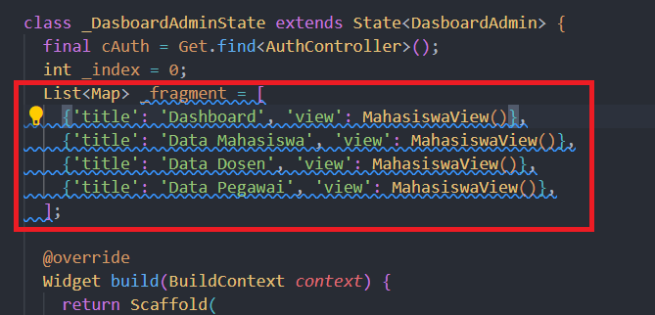

Menjadi

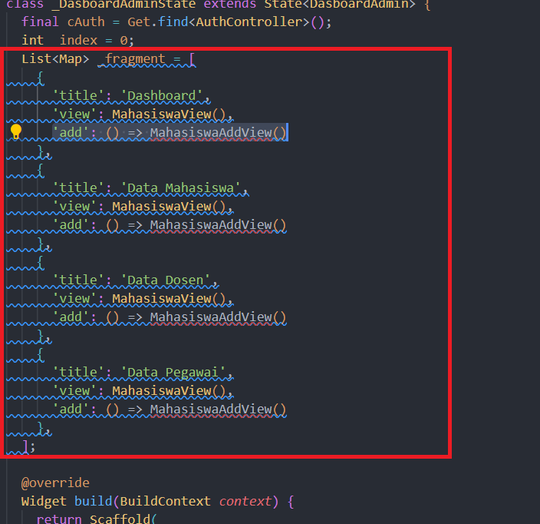

1. Jika code **MahasiswaAddView()** masih error, lakukan ctrl+spasi pada kode tersebut
2. Didalam App bar, tambahkan code berikut

actions: [

IconButton(

onPressed: () => Get.to(_fragment[_index]['add']),

icon: Icon(Icons.add_circle_outline),

)

],

Hasil nya sebagai berikut

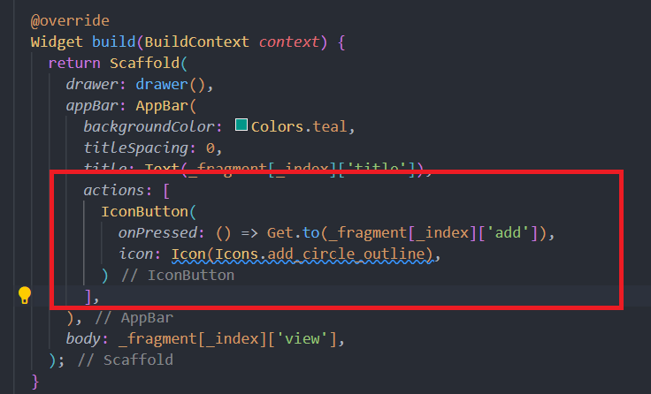

1. Edit file **mahasiswa_add_view.dart** difolder lib/app/modules/mahasiswa/views/

import 'package:bcdx_11312136/app/modules/mahasiswa/controllers/mahasiswa_controller.dart';

import 'package:flutter/material.dart';

import 'package:get/get.dart';

class MahasiswaAddView extends GetView<MahasiswaController> {

const MahasiswaAddView({Key? key}) : super(key: key);

@override

Widget build(BuildContext context) {

return Scaffold(

appBar: AppBar(

title: const Text('Tambah Mahasiswa'),

centerTitle: true,

),

body: Padding(

padding: EdgeInsets.all(8),

child: Column(

children: [

TextField(

controller: controller.cNpm,

autocorrect: false,

textInputAction: TextInputAction.next,

decoration: InputDecoration(labelText: "NPM"),

),

SizedBox(

height: 10,

),

TextField(

controller: controller.cNama,

textInputAction: TextInputAction.done,

decoration: InputDecoration(labelText: "Nama"),

),

SizedBox(

height: 30,

),

ElevatedButton(

onPressed: () => controller.add(

controller.cNpm.text,

controller.cNama.text,

),

child: Text("Simpan"),

)

],

),

),

);

}

}

1. Edit file **mahasiswa_controller.dart,** tambahkan code di atas @override

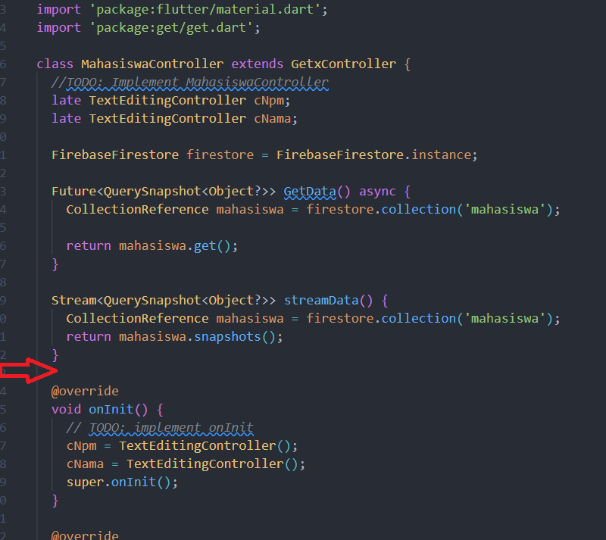

Code nya sebagai berikut

void add(String npm, String nama) async {

CollectionReference products = firestore.collection("mahasiswa");

try {

await products.add({

"npm": npm,

"nama": nama,

});

Get.defaultDialog(

title: "Berhasil",

middleText: "Berhasil menyimpan data mahasiswa",

onConfirm: () {

cNpm.clear();

cNama.clear();

Get.back();

Get.back();

textConfirm:

"OK";

});

} catch (e) {

print(e);

Get.defaultDialog(

title: "Terjadi Kesalahan",

middleText: "Gagal Menambahkan Mahasiswa.",

);

}

}

1. Fitur add data sudah bisa di lakukan testing.

**FITUR UPDATE**

1. Edit file **mahasiswa_controller.dart,** tambahkan code di atas @override, code nya sebagai berikut

Future<DocumentSnapshot<Object?>> getData(String id) async {

DocumentReference docRef = firestore.collection("mahasiswa").doc(id);

return docRef.get();

}

void Update(String npm, String nama, String id) async {

DocumentReference mahasiswaById = firestore.collection("mahasiswa").doc(id);

try {

await mahasiswaById.update({

"npm": npm,

"nama": nama,

});

Get.defaultDialog(

title: "Berhasil",

middleText: "Berhasil mengubah data Mahasiswa.",

onConfirm: () {

cNpm.clear();

cNama.clear();

Get.back();

Get.back();

},

textConfirm: "OK",

);

} catch (e) {

print(e);

Get.defaultDialog(

title: "Terjadi Kesalahan",

middleText: "Gagal Menambahkan Mahasiswa.",

);

}

}

1. Edit file **mahasiswa_update_view.dart** di folder lib/app/modules/mahasiswa/views.

import 'package:bcdx_11312136/app/modules/mahasiswa/controllers/mahasiswa_controller.dart';

import 'package:cloud_firestore/cloud_firestore.dart';

import 'package:flutter/material.dart';

import 'package:get/get.dart';

class MahasiswaUpdateView extends GetView<MahasiswaController> {

const MahasiswaUpdateView({Key? key}) : super(key: key);

@override

Widget build(BuildContext context) {

return Scaffold(

appBar: AppBar(

title: const Text('Ubah Mahasiswa'),

centerTitle: true,

),

body: FutureBuilder<DocumentSnapshot<Object?>>(

future: controller.getData(Get.arguments),

builder: (context, snapshot) {

if (snapshot.connectionState == ConnectionState.done) {

var data = snapshot.data!.data() as Map<String, dynamic>;

controller.cNpm.text = data['npm'];

controller.cNama.text = data['nama'];

return Padding(

padding: EdgeInsets.all(8),

child: Column(

children: [

TextField(

controller: controller.cNpm,

autocorrect: false,

textInputAction: TextInputAction.next,

decoration: InputDecoration(labelText: "NPM"),

),

SizedBox(

height: 10,

),

TextField(

controller: controller.cNama,

textInputAction: TextInputAction.done,

decoration: InputDecoration(labelText: "Nama"),

),

SizedBox(

height: 30,

),

ElevatedButton(

onPressed: () => controller.Update(

controller.cNpm.text,

controller.cNama.text,

Get.arguments,

),

child: Text("Ubah"),

)

],

),

);

}

return Center(

child: CircularProgressIndicator(),

);

},

),

);

}

}

1. Buka file **mahasiswa_view.dart** , edit code ini

ListTile(

onTap: () {},

title: Text('Update'),

),

Menjadi

ListTile(

onTap: () {

Get.back();

Get.to(

MahasiswaUpdateView(),

arguments: id,

);

},

title: Text('Update'),

),

1. Jika code MahasiswaUpdateView() masih error, lakukan ctrl+spasi
2. Fitur update sudah bisa dilakukan testing
3. Untuk membuat fitur delete, edit code ini

ListTile(

onTap: () {},

title: Text('Delete'),

),

Menjadi

ListTile(

onTap: () {

Get.back();

controller.delete(id);

},

title: Text('Delete'),

),

1. Buka file **mahasiswa_controller.dart,** tambah code berikut di atas @override

1. Fitur delete sudah bisa dilakukan testing.

void delete(String id) {

DocumentReference docRef = firestore.collection("mahasiswa").doc(id);

try {

Get.defaultDialog(

title: "Info",

middleText: "Apakah anda yakin menghapus data ini ?",

onConfirm: () {

docRef.delete();

Get.back();

Get.defaultDialog(

title: "Sukses",

middleText: "Berhasil menghapus data",

);

},

textConfirm: "Ya",

textCancel: "Batal",

);

} catch (e) {

print(e);

Get.defaultDialog(

title: "Terjadi kesalahan",

middleText: "Tidak berhasil menghapus data",

);

}

}